IBM ASSIGNMENT 2

|  |  |
| --- | --- |
| Team ID | Team ID: PNT2022PMID49593 |
| Project Name | Project – PLASMA DONOR APPLICATION |
| Name | S.Nanthini |
| Roll No | 950019194031 |

**1.Create registration page in html with username, email and phone number and by using POST method display it in the next html page.**

**app.py :**

from flask import Flask, render_template, request, redirect

app = Flask(_name_)

@app.route('/')

def home():

return 'Welcome! <a href="/login">Register here</a>'

@app.route('/login', methods=['POST', 'GET'])

def login():

if request.method == 'POST':

userName = request.form['userName']

userEmail = request.form['userEmail']

userPassword = request.form['userPassword']

return redirect('/')

return render_template("form.html")

if _name=='main_':

app.run(debug=True)

**form.html :**

<form method="POST">

<div class="form-inline">

<div class="form-group">

<input type="text" class="line-input" name="userName" placeholder="Username">

</div>

<div class="form-inline">

<div class="form-group">

<input type="email" class="line-input" name="userEmail" placeholder="Email">

</div>

<div class="form-group">

<input type="password" class="line-input" name="userPassword" placeholder="Password">

</div>

</div>

<div class=" form-group">

<button type="submit" class="btn btn-light text-primary btn-block" style="margin : 20px 20px -10px 0px">Register</button>

</div>

</form>

OUTPUT:

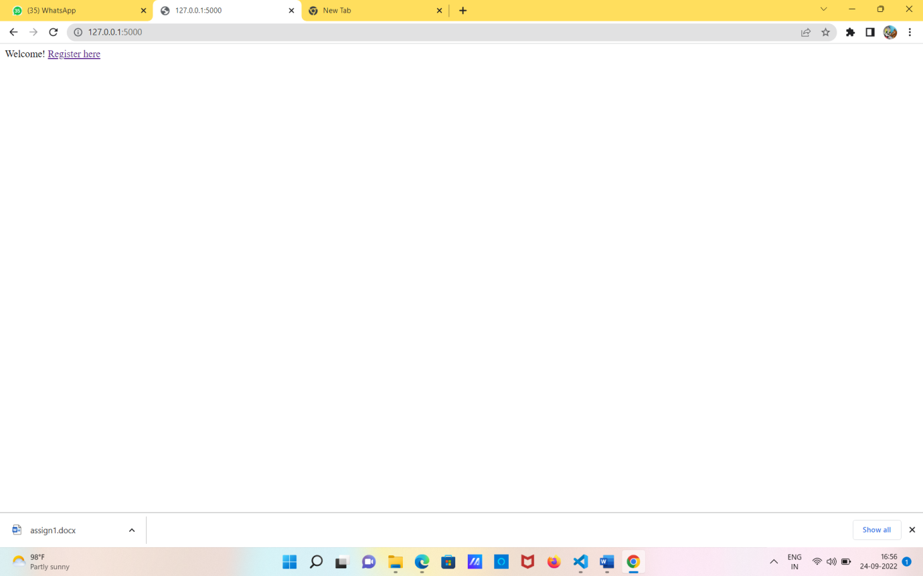

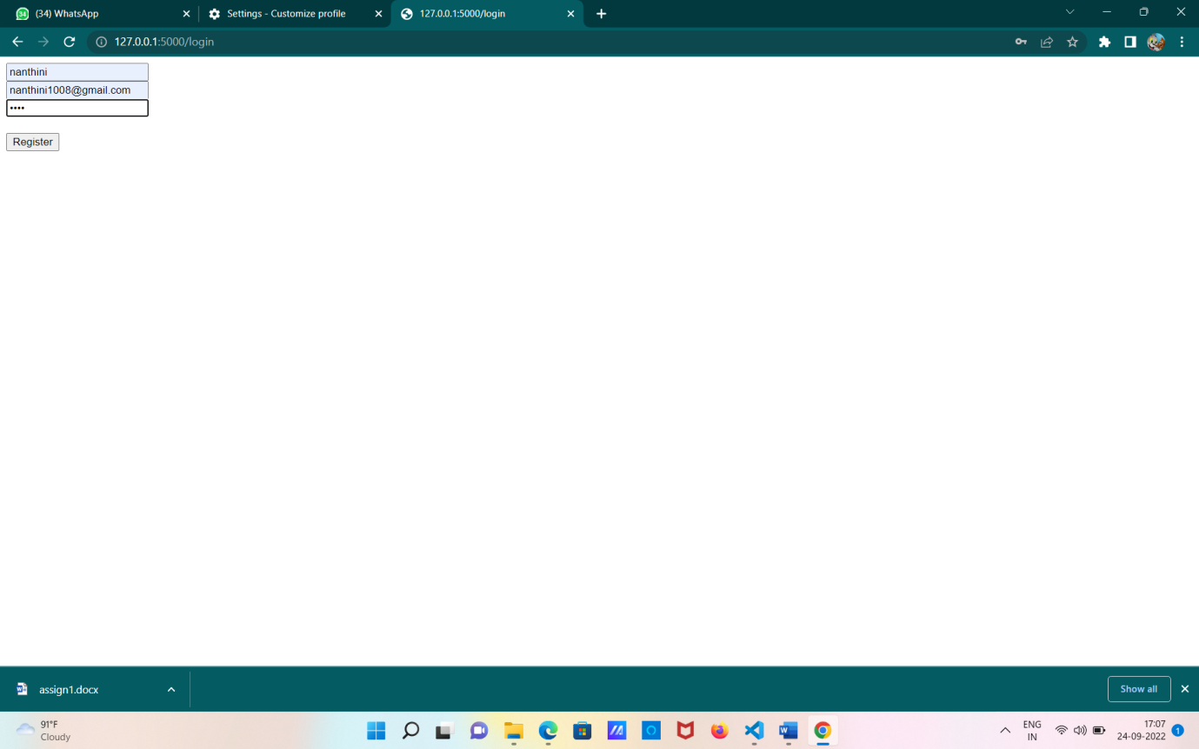

**2.Develop a flask program which should contain atleast 5 packages used from pypi.org**

**PACKAGES:**

import camelcase

from jinja2 import Template

import requests

from flask import Flask

import numpy as np

#numpy

arr = np.array([1, 2, 3, 4, 5])

print("       NUMPY          ")

print(arr)

print(type(arr))

print("\n")

#requests

r = requests.get('https://api.spotify.com/')

r.status_code

print("         REQUESTS      ")

print(r.headers)

print("\n")

#jinja2

template = """hostname {{ hostname }}"""

data = {"hostname": "nanthini"}

j2_template = Template(template)

print("      JINJA2           ")

print(j2_template.render(data))

print("\n")

#camelcase

c = camelcase.CamelCase()

txt = "im a good girl"

print("       CAMELCASE        ")

print(c.hump(txt))

print("\n")

**OUTPUT:**

